Profile Page

Yodel Page

Main Login Page

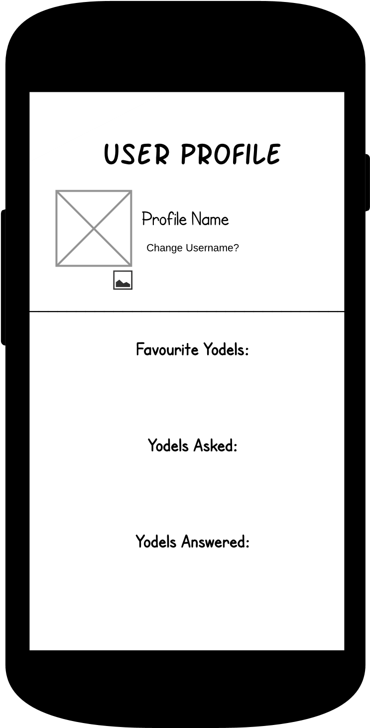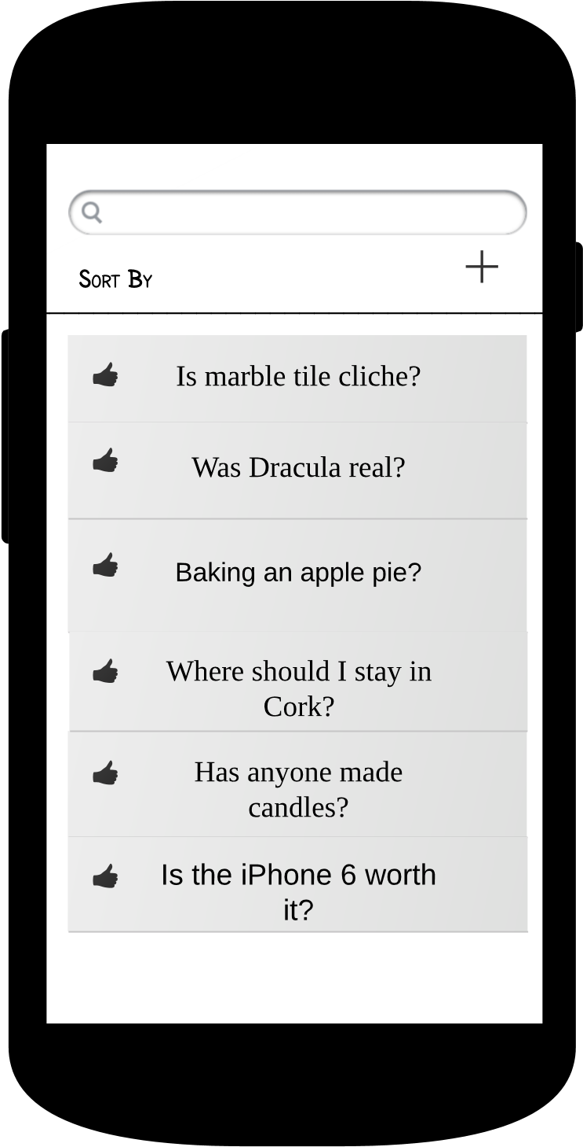



User Profile page. Users can view favourite Yodels and Echos, change username and profile picture.

List of Yodels under a topic. Users can search from here, sort Yodels and add a new Yodel.

Login Page. This is the first page in entering the app.

Accent

Accent

Primary

Colour Scheme

Echo Page

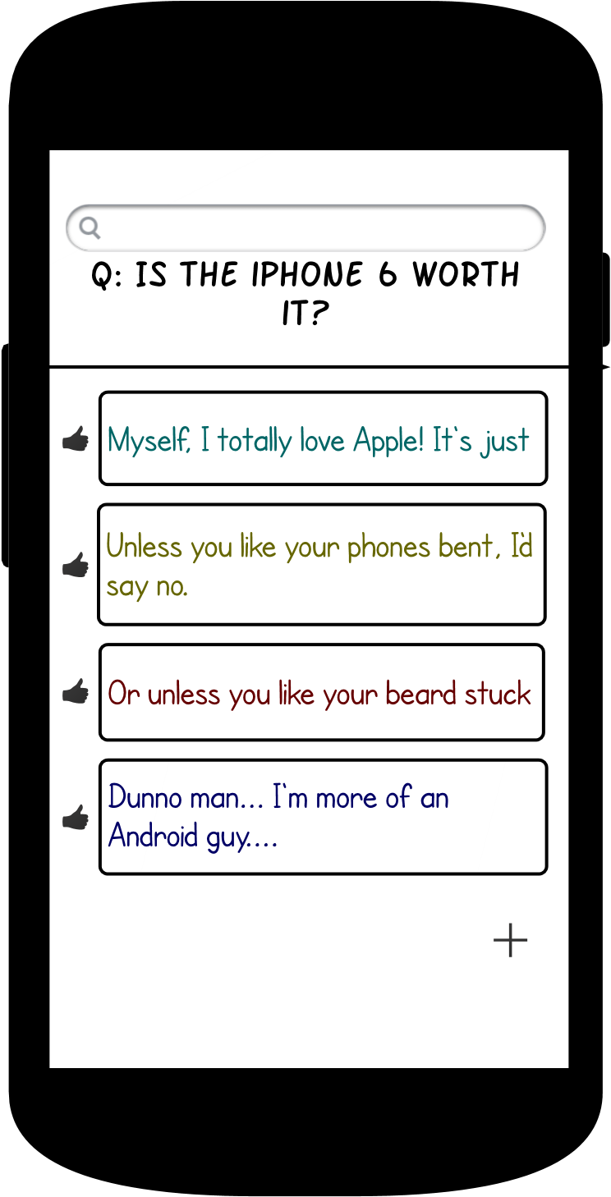

Secondary

List of Echos for a specific Yodel. Here users can add new Echos and view other’s Echos.